# *CLOUD RELATIONS*

***For String Quartet with fixed Electroacoustic Stereo Track.***

*Violin 1 and 2 should be placed on the two extremes of the stage, with the Violoncello at the center and back of the stage. They remain seated. Viola should be able to sit behind the audience, with enough room to stand up and move around. Two speakers must be placed behind the violins, and the stereo must be audible. The room should remain dark the whole time, except for stopwatches that illuminate the players. If stopwatches have no light, there should be individual, portable lights facing each player. Relations last 15- 30 seconds long. The whole piece should last around 13 minutes. The players -and not the electroacoustic track- must end the piece. The overall dynamic of the piece is* ***slow*** *and* ***quiet****.*

1. Each player has to play 9 (nine) sounds as **INITIATORS**, that may or may not cause the **Cloud Relations**:
   1. Players should use all of the following techniques.
      1. Sul tasto
      2. Sul pont
      3. Arco on the side of the instrument
      4. Flautato
      5. Col legno
      6. Pizzicato
      7. Tremolo (with arco or pizz.)
      8. Vibrato
      9. Adding noise with air (with any vowel or with fricative consonants ‘f’ or ‘s’)
   2. At least 3 of them should be combined in any way:
   3. Players should use all of the following pitches (in those registers, but in any string).
      1. At least 3 of them should be played in harmonics (in *any* register).
      2. Double strings may be used combining any of the pitches.
      3. The order should not be neither pre-established, nor the one expressed in the following fragments:
         1. Violin 1:

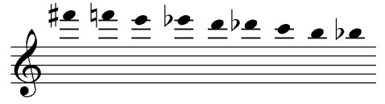

* + - 1. Violin 2:

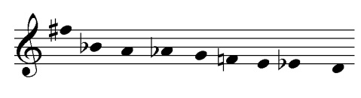

* + - 1. Viola:

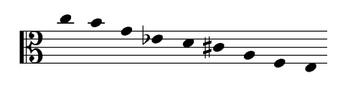

* + - 1. Violoncello:

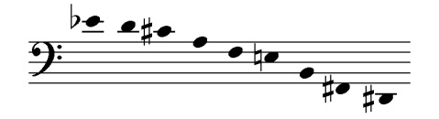

1. Players should decide whether to **FOLLOW** another sound (from the other players or from the electroacoustic track) or **NOT TO FOLLOW**.
   1. When *following*, the sound played can be any sound except the pitches used as *initiators*.
   2. The *following* should be played with an idea of resonance in mind, you can:
      1. Extend
      2. Oppose
      3. Repeat
      4. Merge with the sound
      5. Any other resonance you can think of (with your instrument, body or any element)
   3. *Not following* can mean to:
      1. Keep doing what you are doing
      2. Remain silent
      3. Initiate another sound.
2. **PARENTHESIS 1**: a *parenthesis*has to be played after half the piece has passed.
   1. **Viola** should play the middle **D**, in ***pppp***, sul G, and with 30-90 seconds duration:
   2. Others have to:
      1. Stop doing what they are doing when they realize this is happening.
      2. One player should play the same pitch.
      3. The two remaining players should each play an adjacent minor second: **Eb** and **Db**.
      4. Play in ***pppp***. Use any of the given techniques. Duration is determined by Viola.
3. Very important: Once you start a pitch, maintain that pitch. Never adjust the tuning or suddenly change pitches if the pitch is not exact, or not a desired one.
4. The **ELECTROACOUSTIC STEREO TRACK** should be synchronized with the stopwatches so that everything starts at the same time, or within the same second.
5. Special indications for **VIOLA**:
   1. Three chairs should be left empty behind the audience (center, left and right) for the player to sit and play and move freely between the three places.
   2. You can do any of the following actions at any time, but they should also be performed at the given times. They should be performed very, very slowly and in the lowest audible dynamic:
      1. A glass should be filled with water up to its half (3:15)
      2. A soda can should be opened (6:43)
      3. A chair should be pushed for 5-10 seconds (7:10)
      4. A plastic bag should sound for 10-25 seconds (8:00)
      5. One time only: one action (of your choosing) to follow a sound from the electroacoustic stereo track.
   3. These actions can replace any of your initiators, *but not the parenthesis*.
6. **ENDING**: Before the tape ends (11:00) -or if it already ended-, the players should start **PARENTHESIS 2**:
   1. The same as before but transposed in any interval;
   2. Any player except Viola should start. The others should follow, maintaining the previous relations.
7. Players should not use a score or any visual aid other than a stopwatch. They should try to remember what to do. However, it is ok if some things are forgotten, just keep on playing.
8. These are not rules, they are suggestions. Therefore, ‘cheating’ does not apply; players or audiences may disagree, but they are still invited to keep on playing.

**Federico Cámara Halac,**

**NYC, Nov. 2013**